

**INDIAN INSTITUTE OF INFORMATION TECHNOLOGY, NAGPUR**

C/o Regional Telecom Training Centre (RTTC) BSNL, Seminary Hills, Nagpur-440006 091-0712-2801369, Email: registrar@iiitn.ac.in

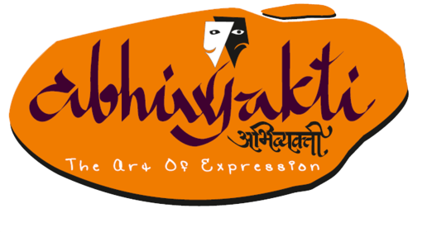---------------------------------------------------------------------------------------------------------------------------------------------------

Presents

Big Roar(“Debate”)



**About the Event:**

You, your stage, your mike and your audience. Go, perform.

It takes less than two minutes to judge how one speaks and how witty he can be. Are you a quick-thinker, always thinking about good comebacks and wanting to showcase your sensible side and speaking ability? Do you think you have what it takes to speak, be wise and impress people? Then this is your chance to be your best at one of the biggest Debating events!   
So, the bottom line, in short is, you cannot miss this one for anything else in the world!

**Rules:**

* Participants have to register online by filling up the google forms provided on the official website www.abhivyakti.ga.
* Participants must possess a valid college identity card of their institution.
* There are two teams, each consisting of maximum Two speakers.
* Each team has two or three constructive speeches, and two to three rebuttal speeches. The affirmative gives the first constructive speech, and the rebuttals alternate: negative, affirmative.
* When worded as a proposition of policy, the topic requires the affirmative to support some specified action by some particular individual or group.
* The affirmative has the right to make any reasonable definition of each of the terms of the proposition. If the negative challenges the reasonableness of a definition by the affirmative, the judge must accept the definition of the team that shows better grounds for its interpretation of the term.
* The affirmative must advocate everything required by the topic itself. No revision of position of a team is permitted during the debate.
* He who asserts must prove. In order to establish an assertion, the team must support it with enough evidence and logic to convince an intelligent but previously uninformed person that it is more reasonable to believe the assertion than to disbelieve it. Facts must be accurate. Visual materials are permissible, and once introduced, they become available for the opponents' use if desired.
* In the questioning period, the questioner may ask any fair, clear question that has a direct bearing on the debate. The questioner may use the period to build up any part of his own case, to tear down any part of his opposition's case, or to ascertain facts, such as the opposition's position on a certain issue, that can be used later in the debate. The questioner must confine himself to questions and not make statements, comments, or ask rhetorical questions.
* Each speaker is questioned as soon as he concludes his constructive speech. The witness must answer the questions without consulting his colleagues.
* No new constructive arguments may be introduced in the rebuttal period.
* The affirmative must, if possible, reply to the major negative arguments before the last rebuttal.
* The judge's will base their decision entirely on the material presented, without regard for other material which they may happen to possess.
* Any gains made outside of the established procedure are disallowed.
* You need to get ready at least 10 minutes before the event starts.
* Every participant(s) are required to fill up the “undertaking”.

**Please, do collect your identity cards available at the registration desk.**

**Note:**

* **In case of any discrepancy, decision made by the Team Abhivyakti will be final**
* **The event may be held as various rounds as per the convenience of Team Abhivyakti**
* **Prizes can be changed**

**Registration Fees:**

**Rs 300/- per team**

**Prizes:**

1st Winner : INR 3000

2nd Winner: INR 2000

**Contact Us:**

**Divya sri koshike : 7330901399**

**Ambar Tayde : 8888364377**